# **Enderlin Sofa**

**Details & Overview $584.99**

**Description**

A brilliant take on urban chic styling, the Enderlin sofa in vibrant blue makes high design highly affordable. Distinctive elements include quilted channel stitching for clean-lined allure and a velvety soft fabric you'll love living with. Sculptural track arms up the wow factor. If you’re looking for big style on more modest scale, you’re sure to appreciate this sofa’s space-conscious 82" wide profile.

* Corner-blocked frame
* Attached seat cushion
* High-resiliency foam cushions wrapped in thick poly fiber
* 2 toss pillows included
* Pillows with soft polyfill
* Velvet polyester upholstery and pillows
* Platform foundation system resists sagging 3x better than spring system after 20,000 testing cycles by providing more even support
* Smooth platform foundation maintains tight, wrinkle-free look without dips or sags that can occur over time with sinuous spring foundations

**Fabric Details**

* Body and Pillows: Polyester (100)%
* : Polyester (100)%

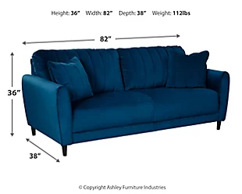**Weight**

112 lbs. (50.8 kgs.)

**Dimensions**

* Width: 82.00"
* Depth: 38.00"
* Height: 36.00"

**Additional Dimensions**

* 22" Toss Pillow Width: .00"
* 22" Toss Pillow Depth: .00"
* 22" Toss Pillow Height: .00"
* Arm height: 26.00"
* Distance between arms: 71.00"
* Leg height: 4.50"
* Minimum width of doorway for delivery: 32.00"
* Seat depth: 21.00"
* Seat height: 19.00"
* Top of cushion to top of back: 18.00"